How to Perform Backup on Tableau Server

Reference Link:
https://help.tableau.com/current/server/en-us/db_backup.htm

Steps need to follow while taking backup of tableau server:
- Open a command prompt as administrator on the initial node (the node where TSM is installed)
- Log in to TSM by running the following command and entering your Tableau Server administrator credentials
- Write the following command by entering your user name and password
tsm login -u <username>
- Once you have log in by providing credentials.
Run the backup command as follow:
tsm maintenance backup -f <backup file path>
- If we want to create a backup schedule named "monthly-backup" that runs on the 15th of each month at 2 am and generates a file calle<yyyy.mm.dd.hh.mm>-ts-mid_month_backup.tsbak
We can use command as follow:
tsm maintenance backup -f ts-mid_month_backup -sr monthly -st 02:00 -sd 15 -sn monthly-backup
- Add --append-date to the command to include the date in the backup file name.
tsm maintenance backup –file backup_file –append-date
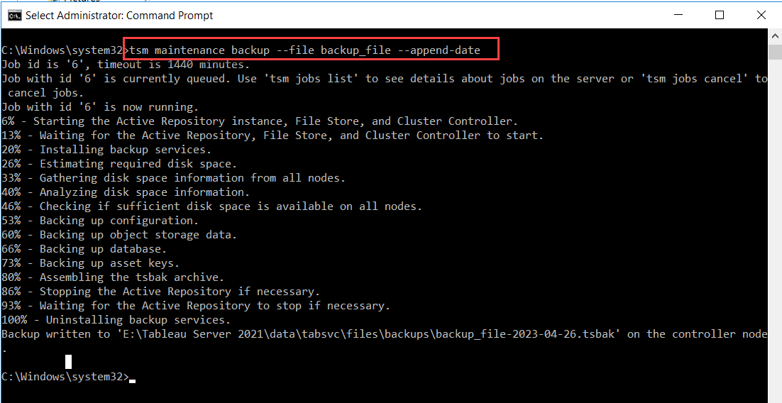
- After following these steps our backup file will be created on the following location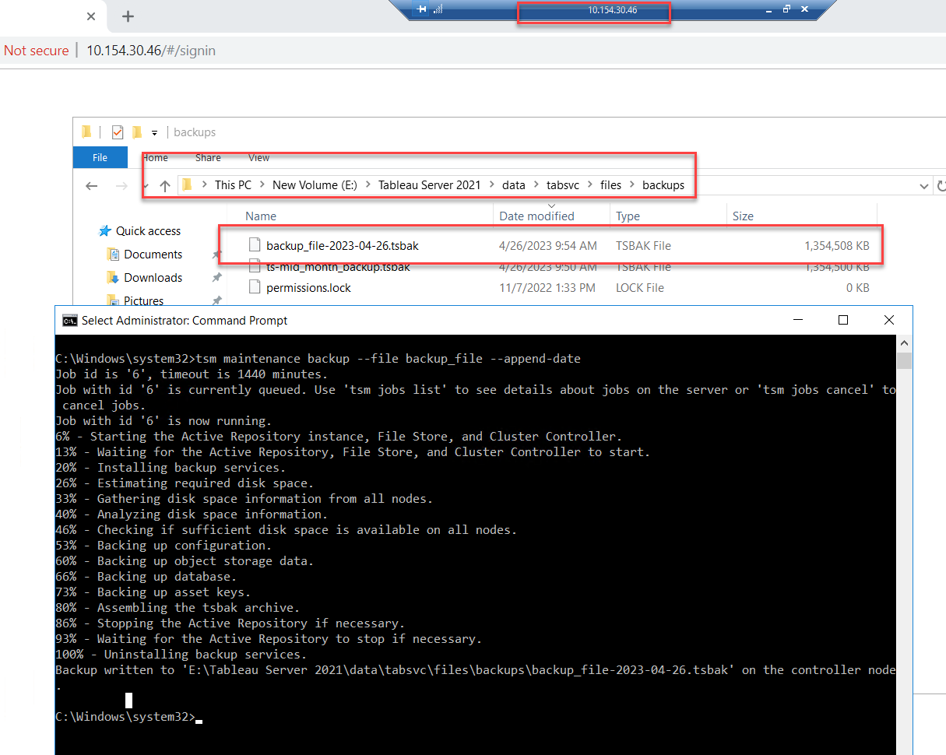
- Wait for the backup to complete. The time it takes to complete the backup depends on the size of your Tableau Server installation.
- Log out of TSM by running the following command:
tsm logout
Note:
By following these steps, you can take a backup of Tableau Server using commands. It's recommended to schedule regular backups to ensure that your data is protected in case of any unexpected failures.

